🔰“Configuring aws ec-2 and joining EBS volume through aws cli ”🔰

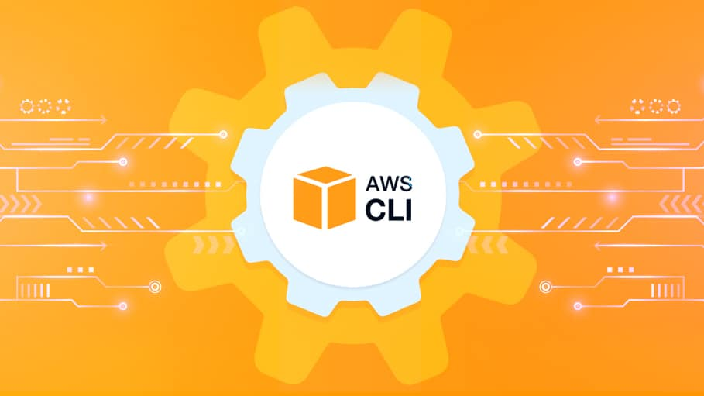

The AWS Command Line Interface (CLI) is a unified tool to

manage your AWS services. With just one tool to download

and configure, you can control multiple AWS services from the

command line and automate them through scripts.

Problem Statement :

1.Create a keypair.

2.Create a Security group.

3.Launch instance using above created keypair and security group.

4.Create EBS volume of 1GB.

5.Final step is to attach the above created EBS volume to the instance you created in previous steps.

Step1. Logging in to my aws using aws configure command.

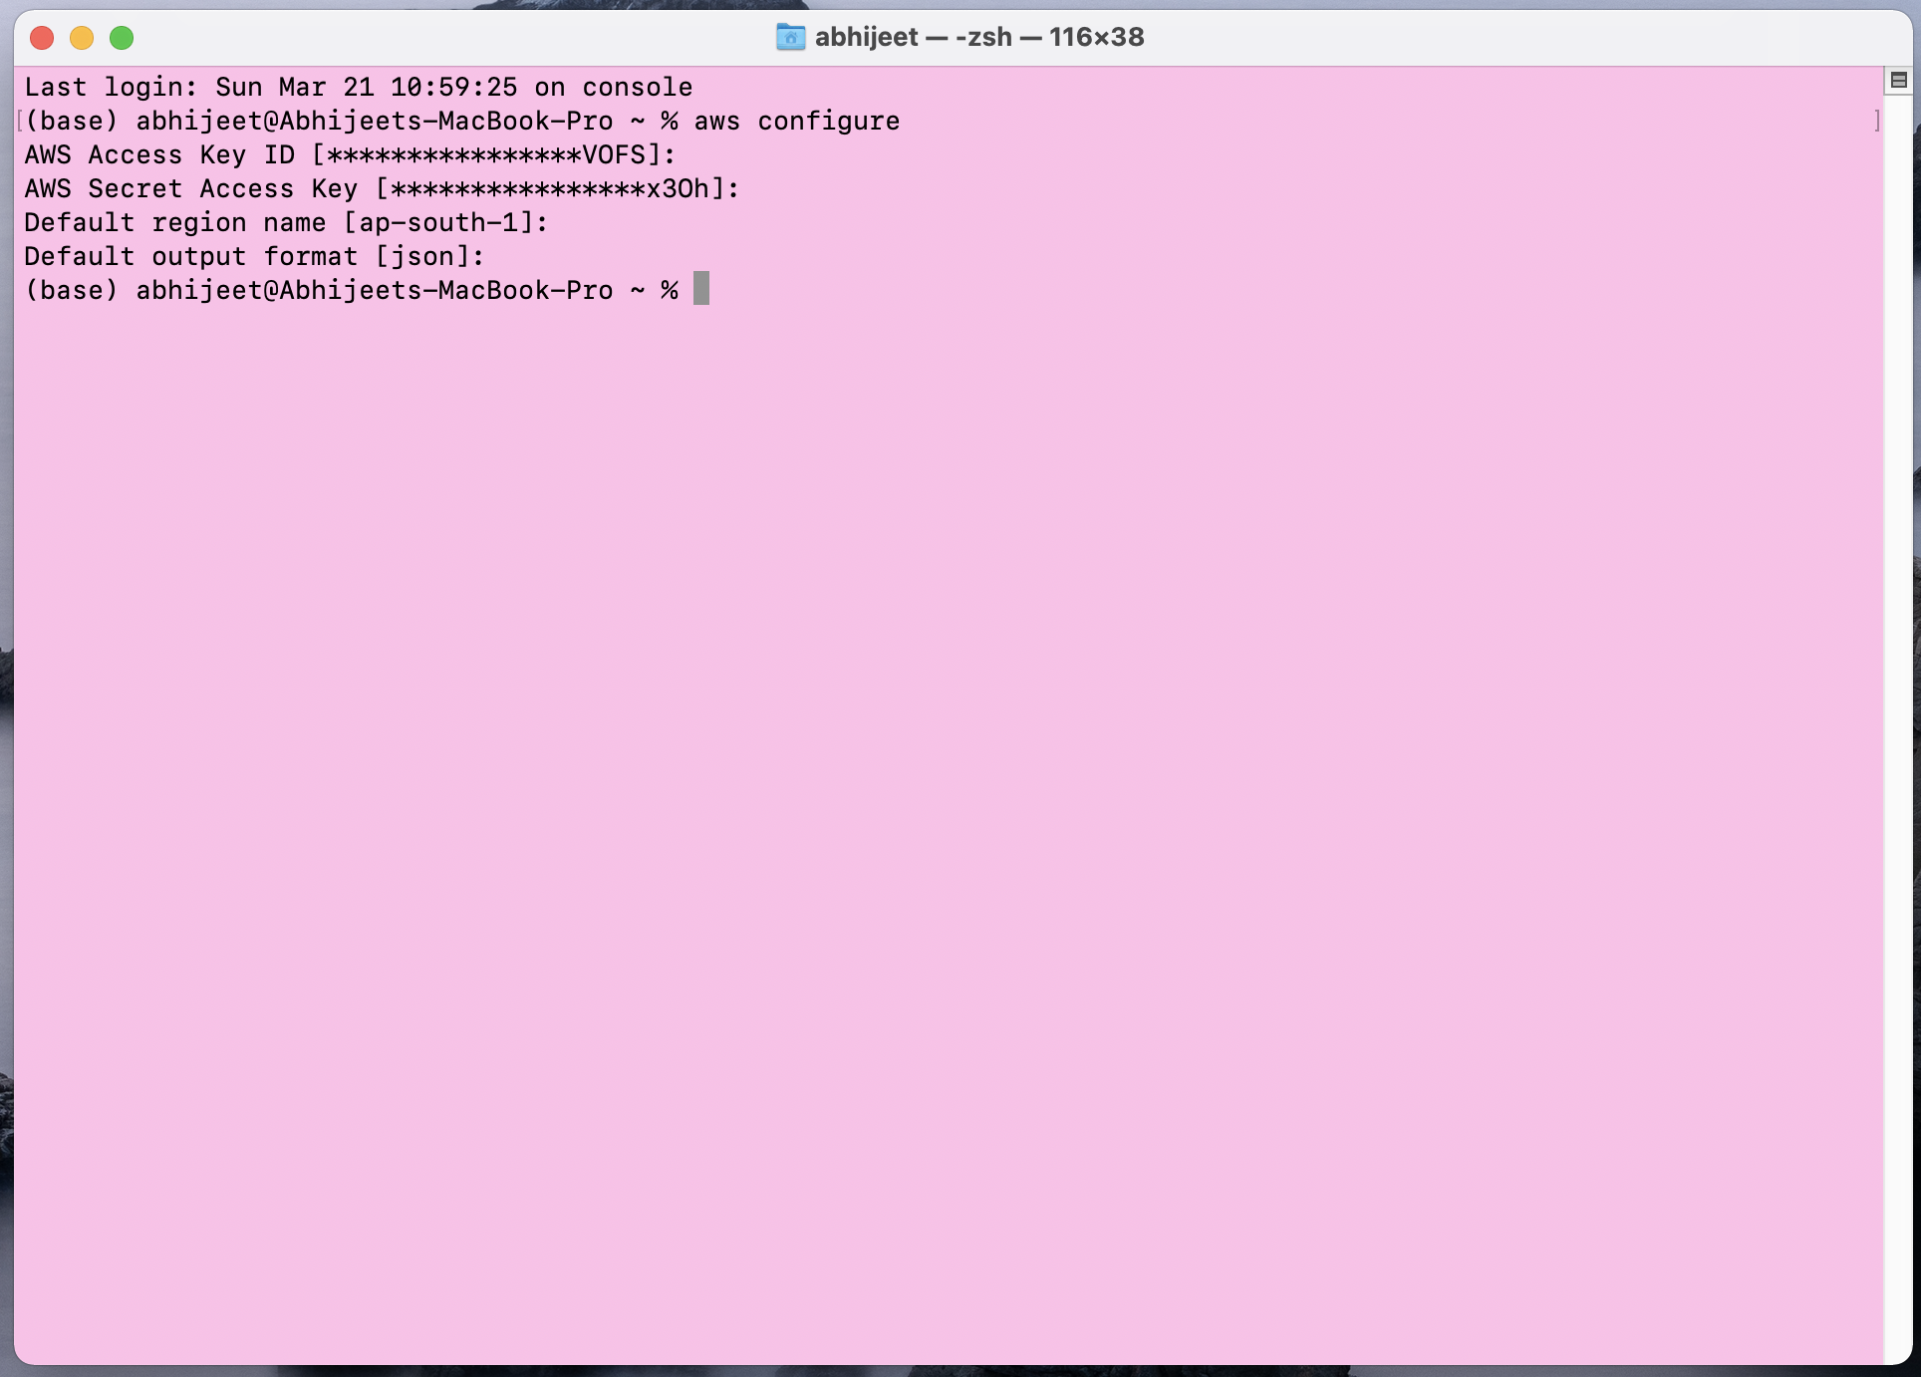

Step2. Creating key-pair through cli.

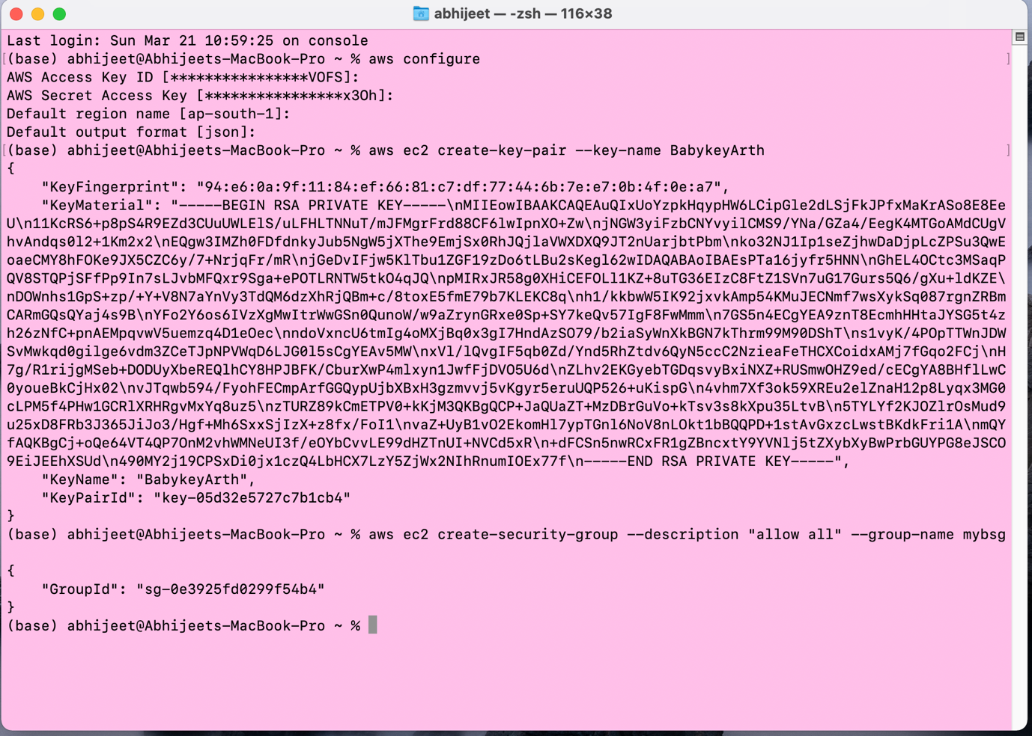

Step3. Checking the key through graphical interface.

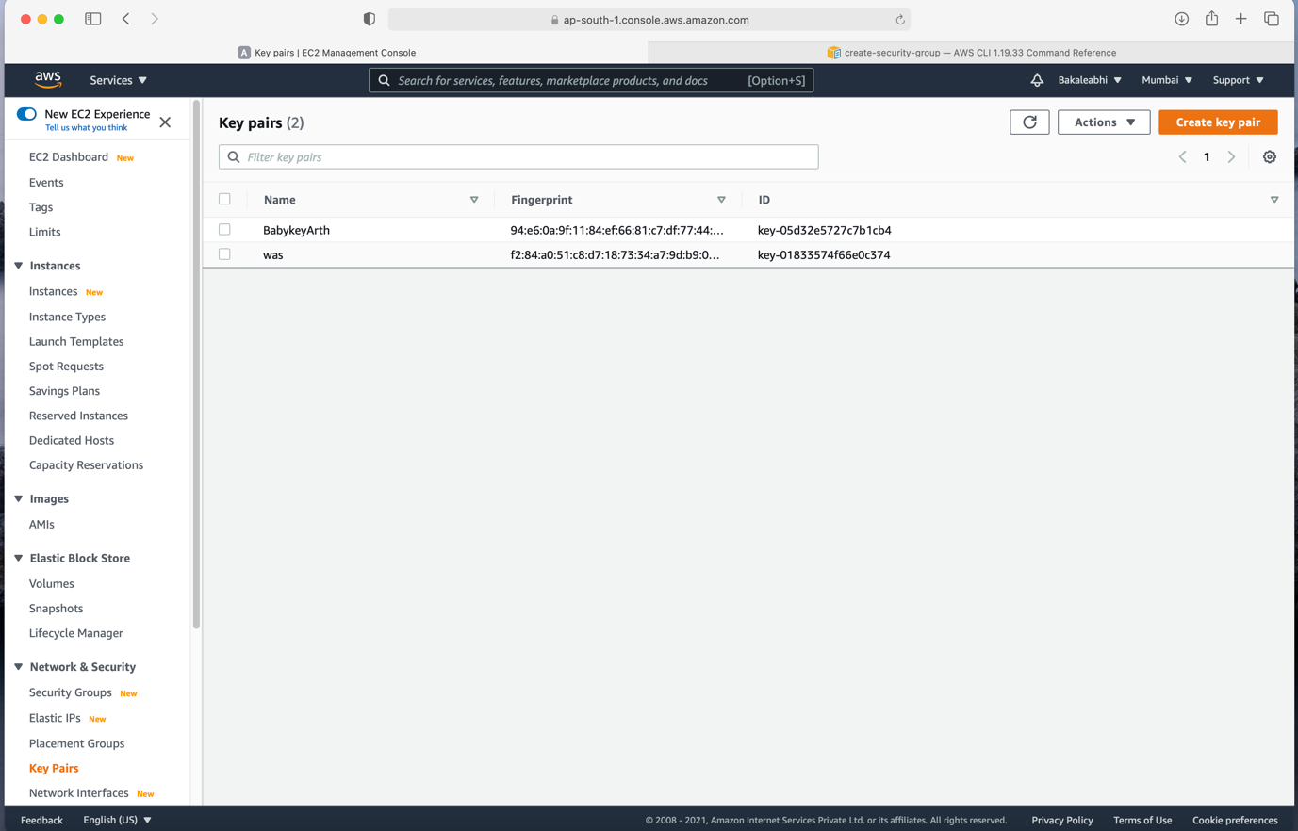

Step4. Creating new security group.

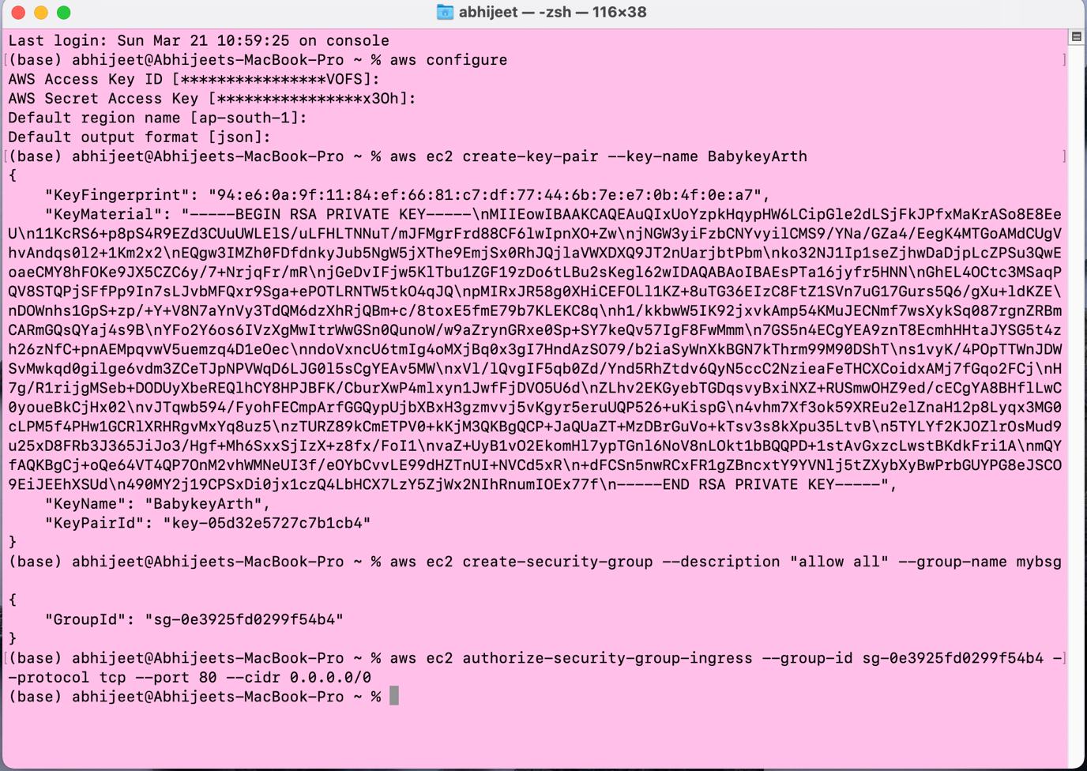

Step5. Checking the Security group through graphical interface.

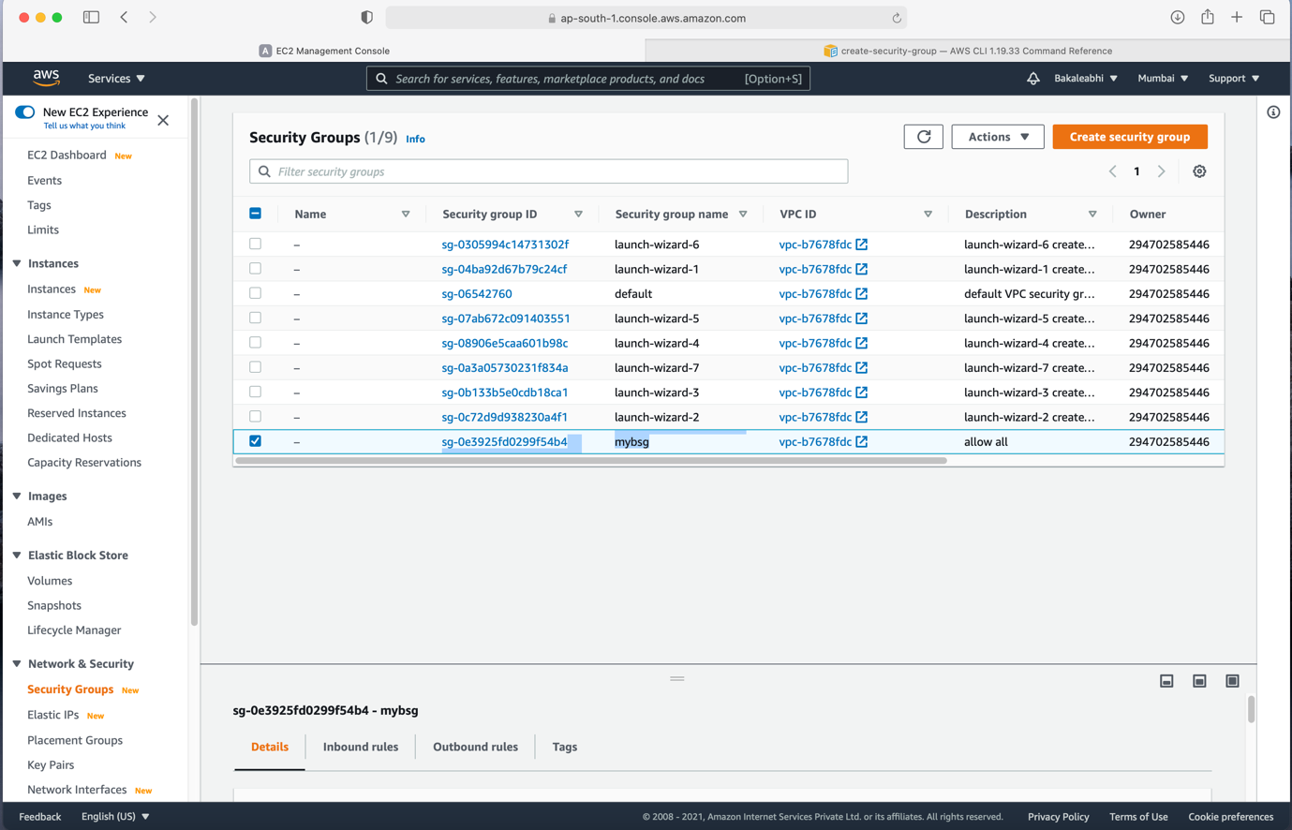

Step6. Launching a ec-2 instance from cli.

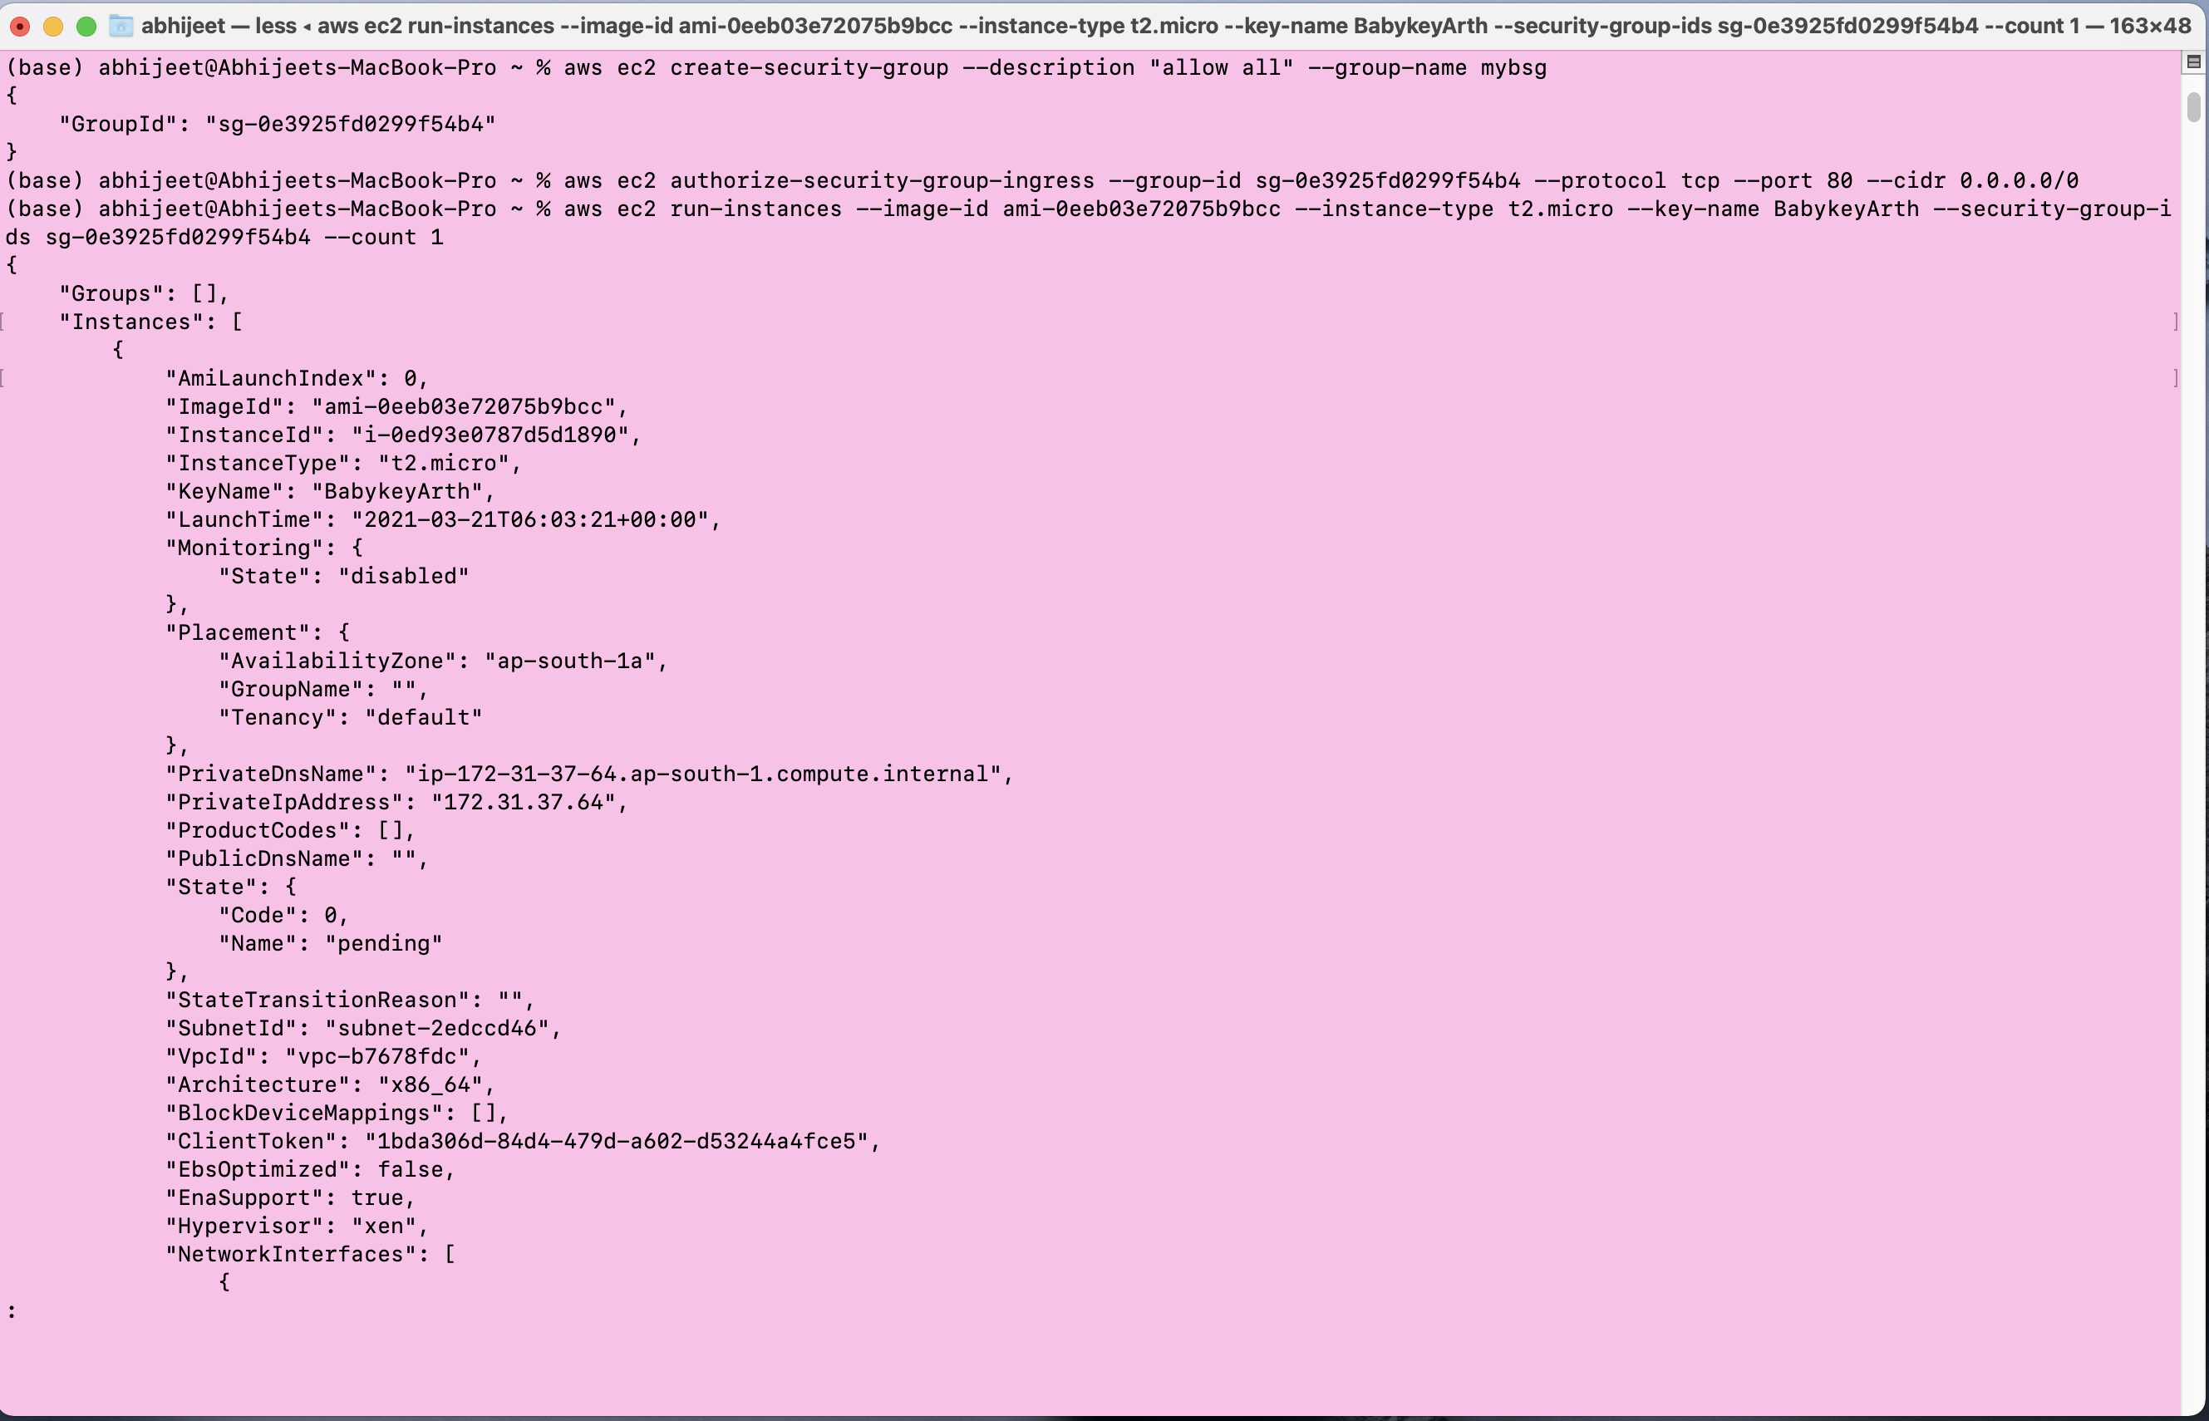

Step7. Checking the launched instance .

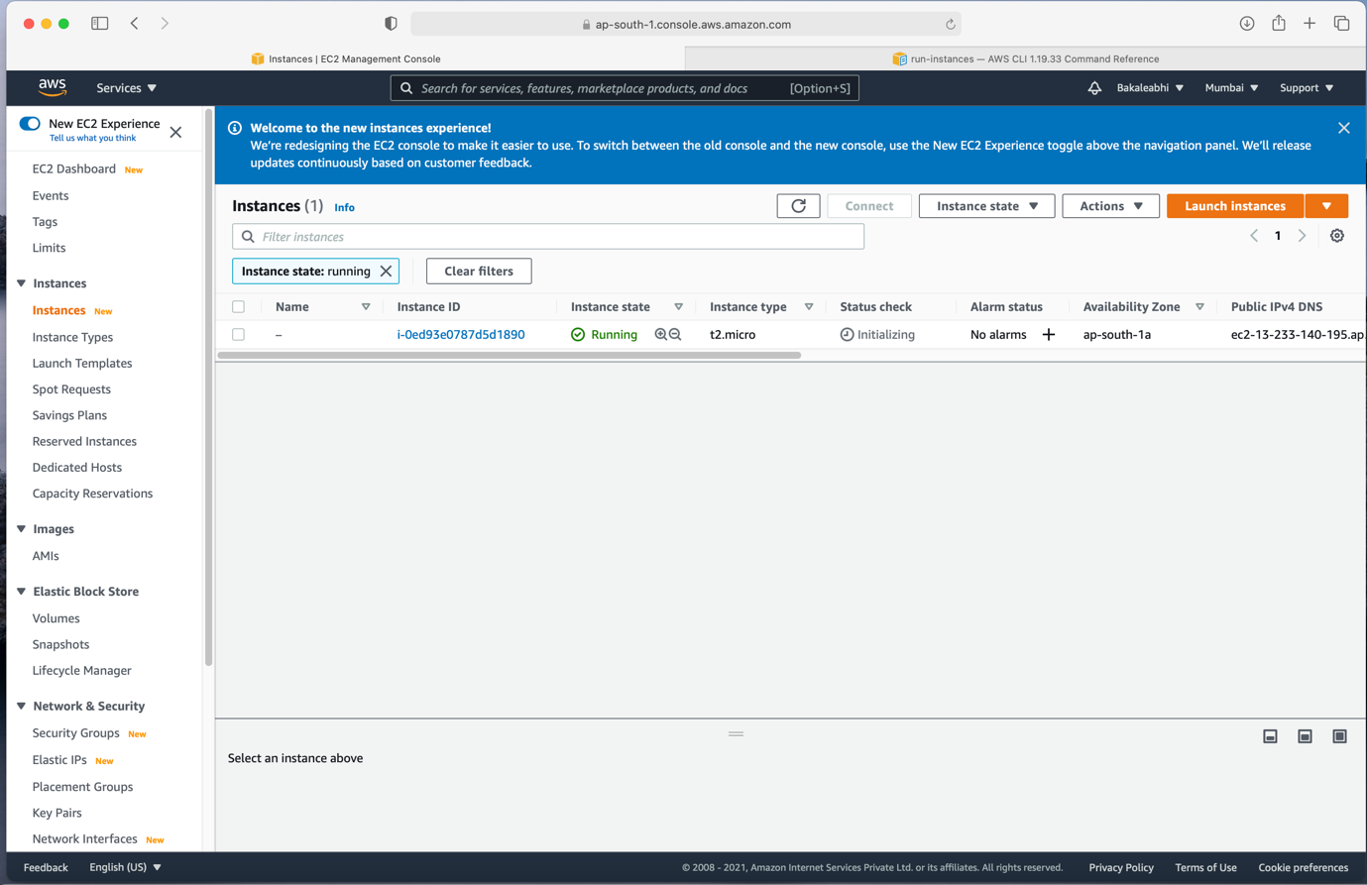

Step8. Creating a EBS volume .

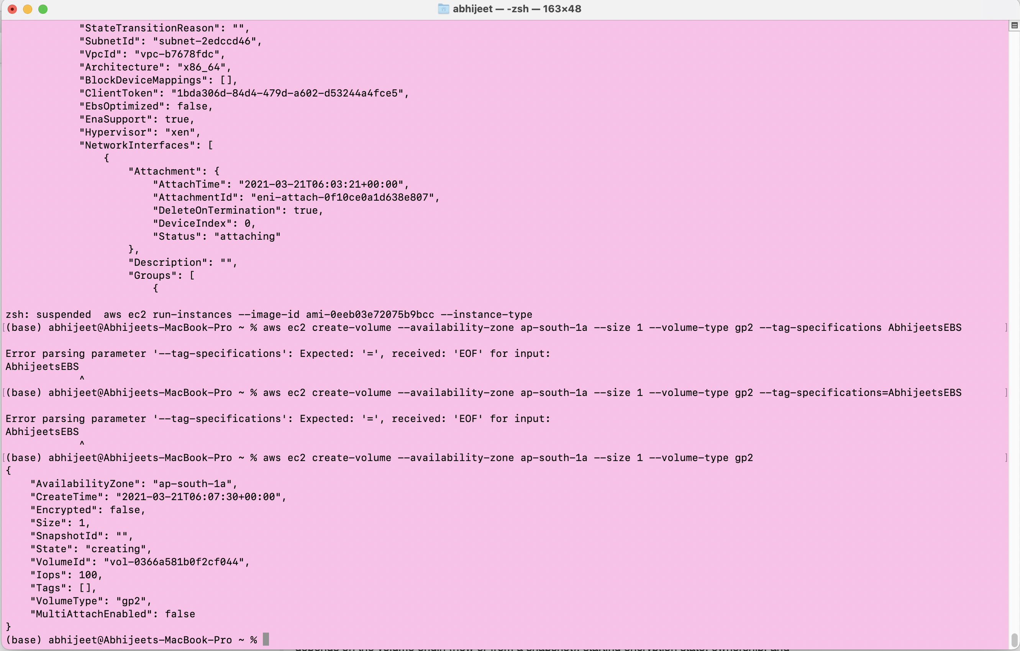

Step9. Checking the EBS Volume is available or not.

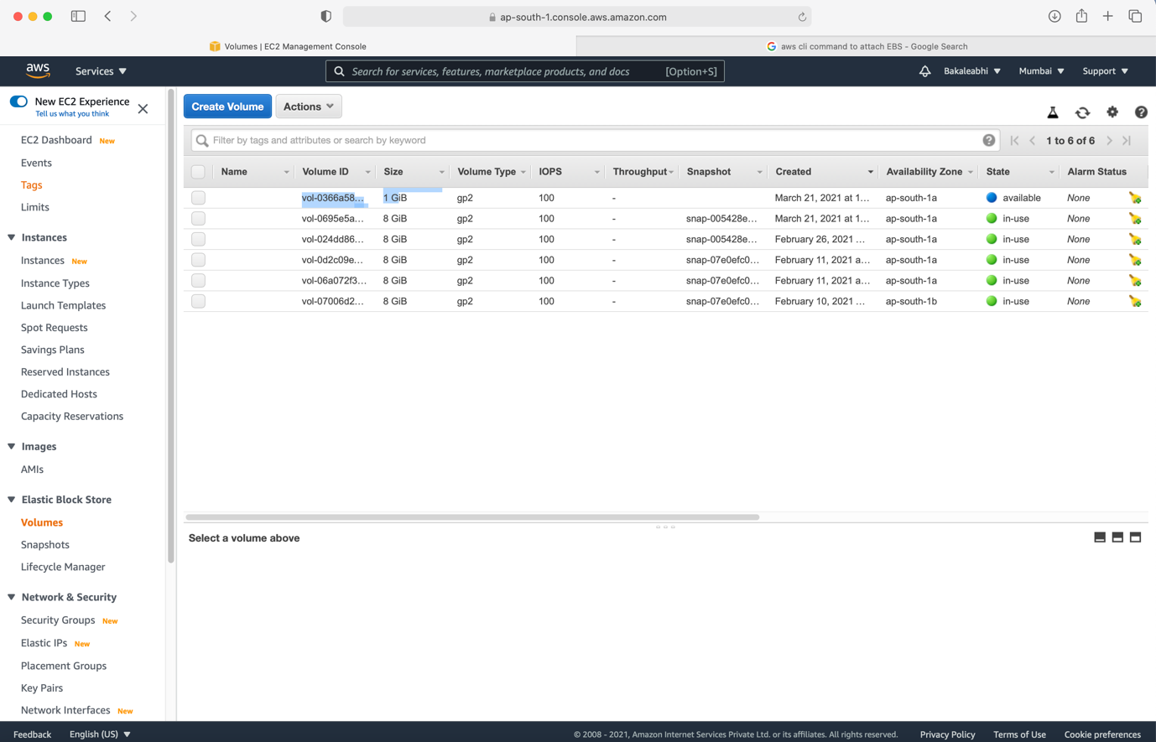

Step10. Attaching the EBS volume to newly created Ec2 instance.

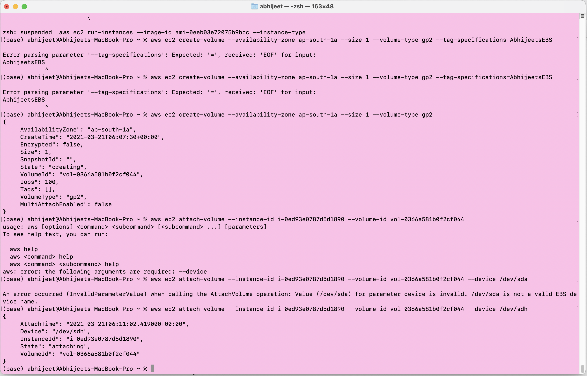

Step11.Checking if the EBS is connected or not and BOOM!! Its connected…. And in use.

